For this final, you will be contributing to Github repository hosted at: https://github.com/NAU-CS/cs205_final

1. [15 points] You will be contributing a new branch based on the fall2022 branch in the cs205_final repository, based on the instructions for contributing to an existing GitHub project in Module 5.
   1. [2.5 points] First fork the NAU-CS/cs205_final repository to a new repository under your github user (your_github_username/cs205_final), then clone your fork.

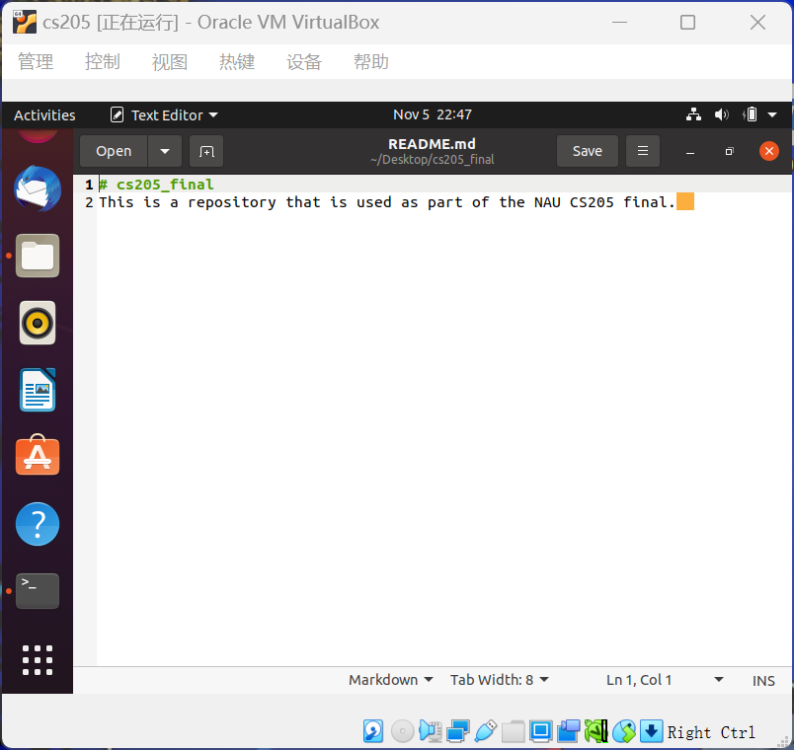

* 1. [2.5 points] Create your own branch based on the**fall2022** branch called **[NAU_ID]_fall2022**where [NAU_ID] should be replaced by your NAU username. For instance, my branch would be named mv668_fall2022.

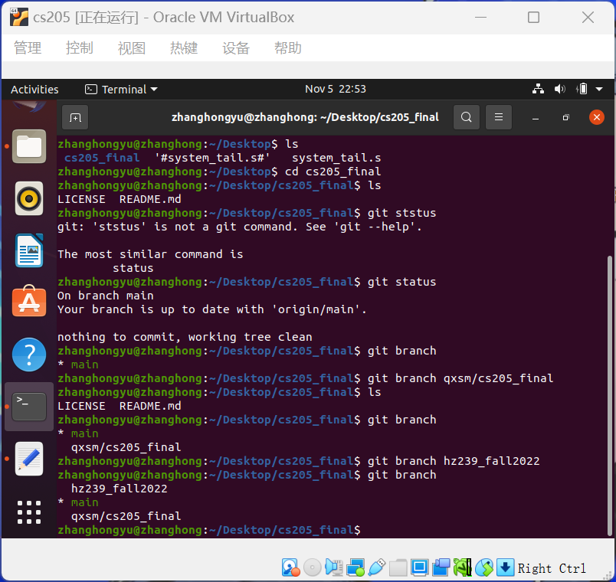

* 1. [2.5 points] Follow the commented instructions in cs205_final_exam.sh to modify cs205_final_exam.sh as directed.

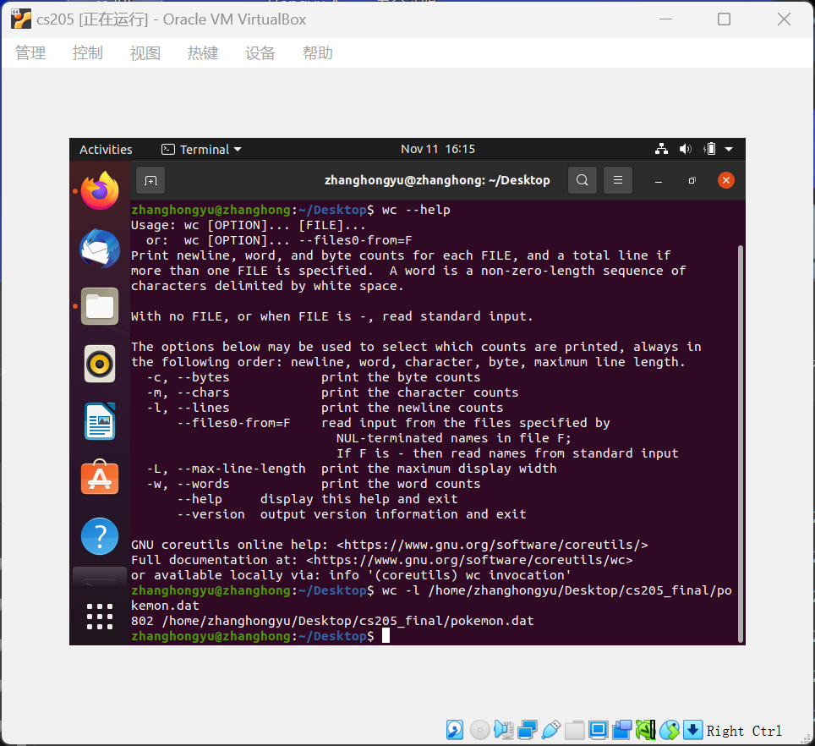

* 1. [2.5 points] in a subdirectory of your local version of the repository called **screenshots**, create a screenshot of the terminal input/output, when you run the command ./cs205_final_exam.sh pokemon.dat

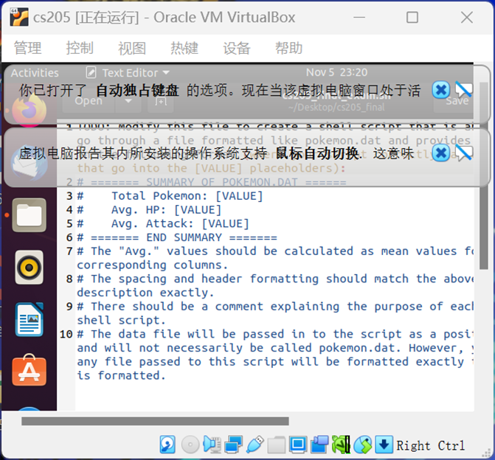

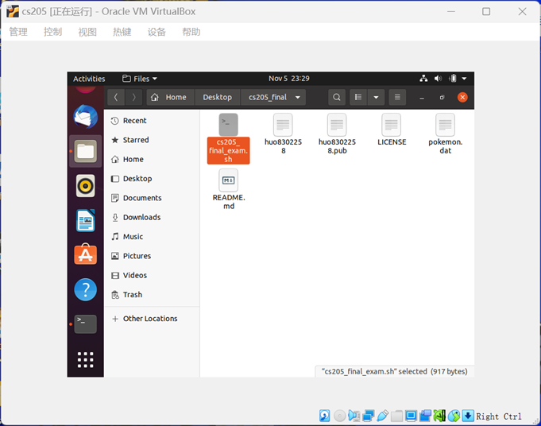

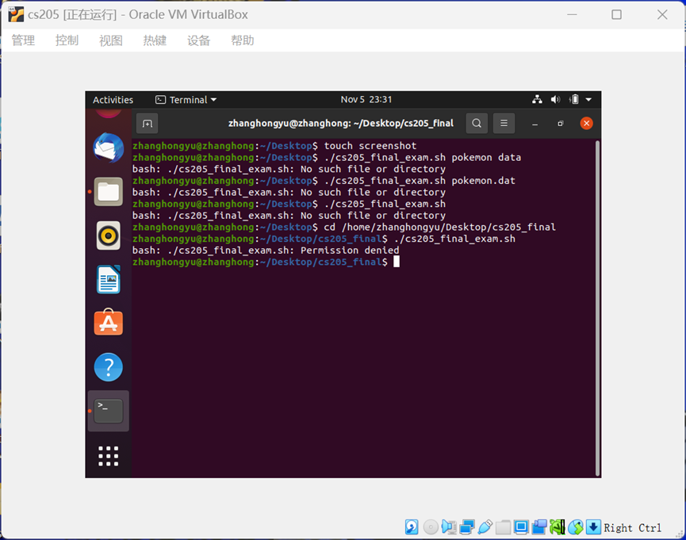

* 1. [2.5 points] Commit all your changes with a commit message that describes your modifications.

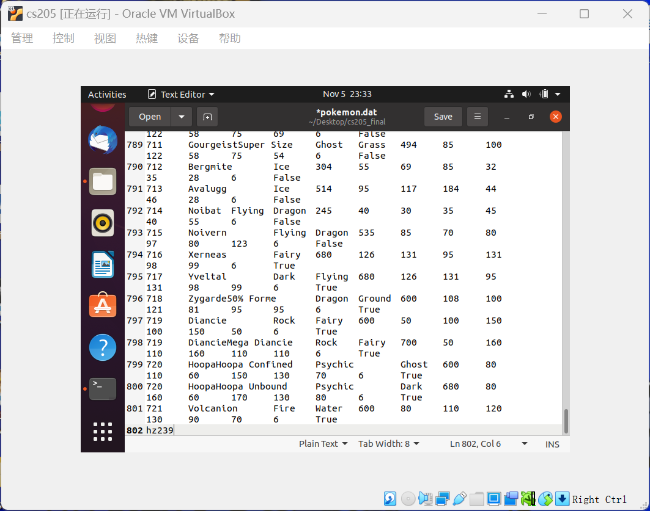

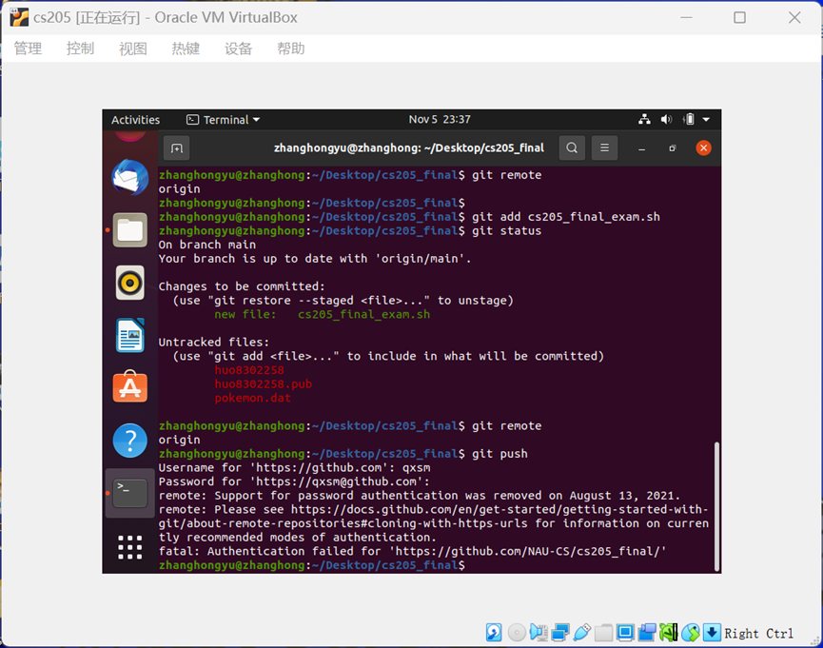

* 1. [2.5 points] Push your changes to github (in your repository, your_github_username/cs205_final, and your new branch, **[NAU_ID]_fall2022**).

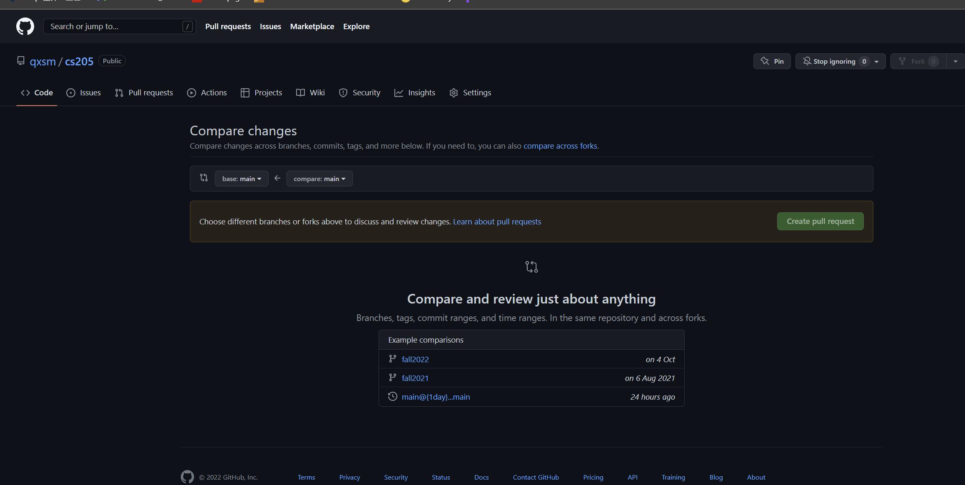

* 1. [5 points] You will create a GitHub pull request for your modifications (base repo: NAU-CS/cs205_final, base branch: fall2022, compare repo: your_github_username/cs205_final, compare branch: **[NAU_ID]_fall2022**).